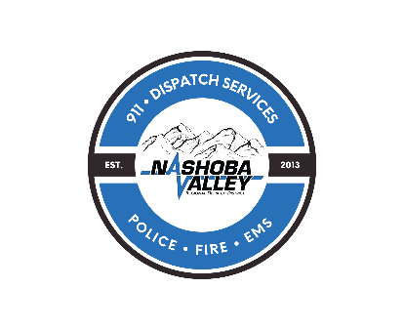
Nashoba Valley Regional Dispatch District
Administration Board Meeting
Agenda

Thursday October 10, 2024
11:00 AM

- Call the Meeting to Order
- Vote to enter into Executive Session pursuant to MGL c. 30A, Section 21 (a) to discuss negotiation strategy with Executive Director.

- Adjourn

